



Technical Specification - SAP Development
Add CA and PO Box / Street no as another option for password reset

Document Reference : Add CA and PO Box / Street no as another
Option for password reset
Version : 001
Author : Mantu Kumar
Date Created : 29-Feb-2016
Document Status : Draft [Draft/Review/Signed Off]

Approval

Approved by | Name | Role | Signature | Date
Process Team Lead
Development Team Lead

Document History

Version | Reason for change | Date | Modified by
1.0 | Initial draft of technical spec | 29-Feb-2016 | Mantu Kumar
1.1
1.2
1.3

Table of Contents

1. General Information 4
2 Description and Purpose 5
3 Assumptions 5
4 Issues 5
5 Technical Solution 6
5.1 Flow Diagram 6
5.2 Pseudo code 7
5.3 BADI/Enhancement Description 9
6 Custom Tables/Structure in SAP 9
7 Error Handling 10
8 Error Messages 10
9 Security Requirements/ Authorization Details 10
10 Unit Test Plan 10

General Information

Functional Design Spec ID:
Report Name/ID:
Report Title:
Implement. Phase
Message Class:
Develop. Class:
Module:
Report Paper Size
Report User/User Group:
Contact Details:
Prepared By |  |  |  | Prep Date:
 | Phone Number:
 | Email Address:
Business/Functional Analyst:
 | Phone Number:
 | Email Address:
Functional Area User Contact:
Primary:
 | Phone Number:
 | Email Address:
Secondary:
 | Phone Number:
 | Email Address:
Run Frequency |  | Languages
Priority: |  | Complexity:
Expected volume:

Transport Information

Version from Document History | Transport Request # | Task # | Object Identifier  (Program ID, Layout Set ID, etc) | Object Type  (Program, Transaction, Layout Set)
1.0 | CRSK900073
1.1 | CRDK900158 | CRDK900160
1.2

Description and Purpose

Allow additional option to user to enter PO Box or street number of provided BUAG (contract account) mailing address during password reset through Mobius.

Reference JIRA Tickets: PRJBWBMBS-22

Assumptions
User knows the contract account and PO Box or Street number of mailing address of the contract account.

Issues
--N/A--

Issue # | Date Raised | Issue Description | Issue Resolution

Technical Solution

Flow Diagram
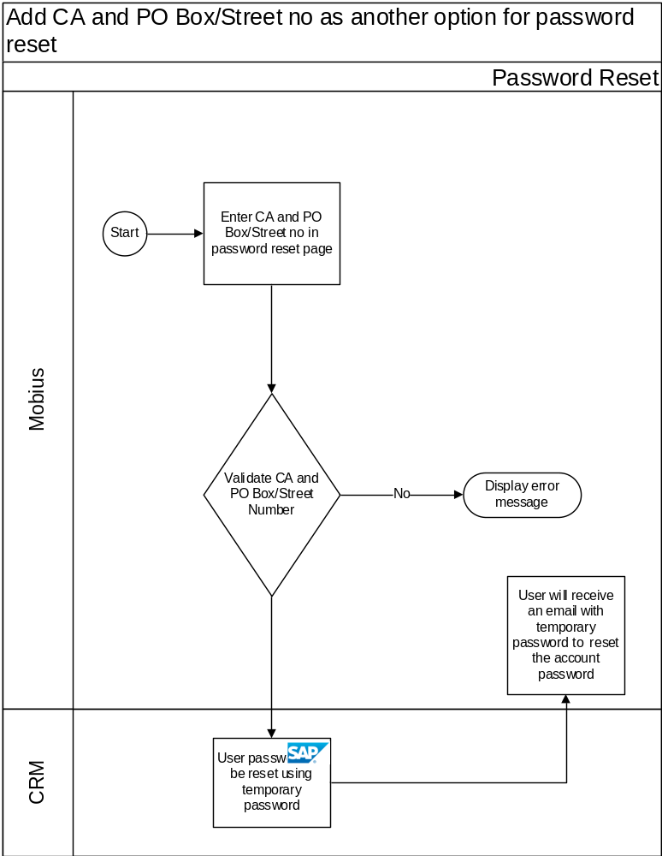

Pseudo code
Model Provider Class -> CL_CRM_IU_UMC_URM_MODEL
New enhancement implementation ZCL_CRM_IU_UMC_URM_MODEL created with Post-Exit implementation for method -> DEFINE
Entity Type -> UserCredentialResetUsingBuag created with Function Import “ResetUserCredentialUsingBuag” as action.
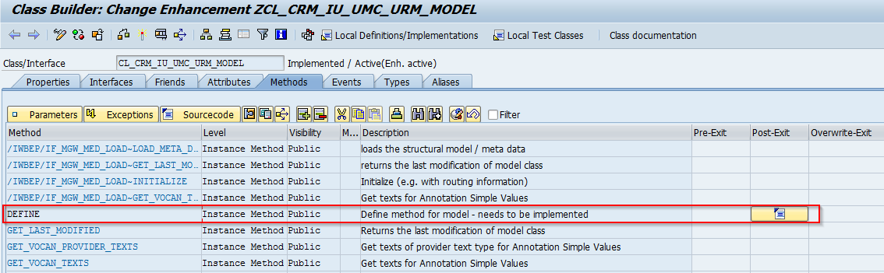
Data Provider Class -> /IWBEP/CL_MGW_URM_DATA
New enhancement implementation ZCL_MGW_URM_DATA created with Post-Exit implementation for method -> /IWBEP/IF_MGW_APPL_SRV_RUNTIME~EXECUTE_ACTION
Function Import Action -> “ResetUserCredentialUsingBuag” is created.
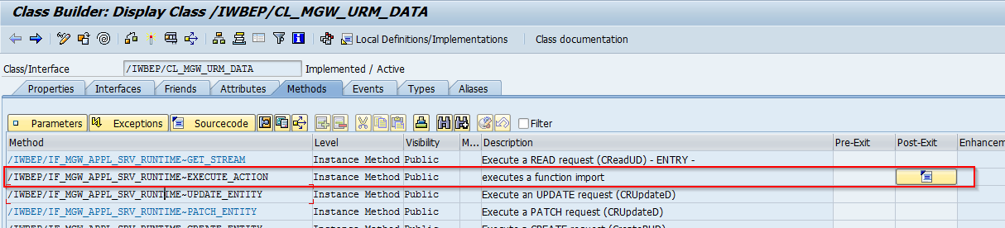

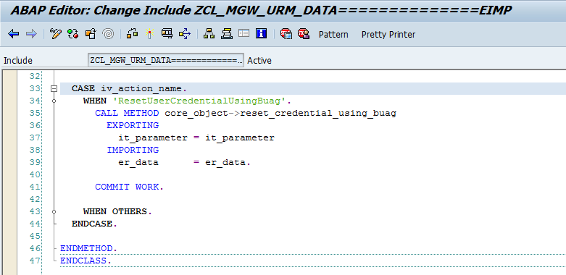

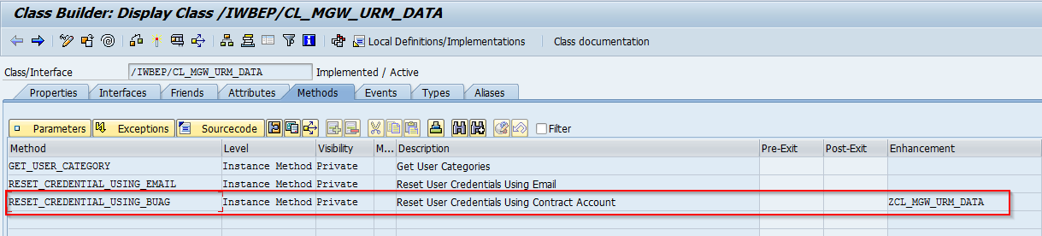

New Enhancement Implementation created ZUTG_MGW_URM_TYPES for interface /IWBEP/IF_MGW_URM_TYPES to declare new type.
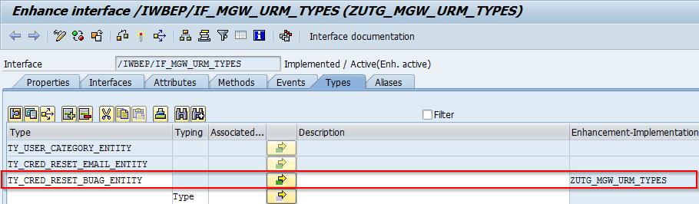

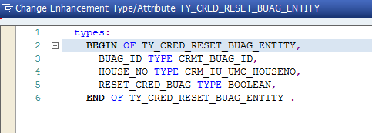

New Message number 999 created for Message Class -> ZCRM_IU_UMC_ODATA
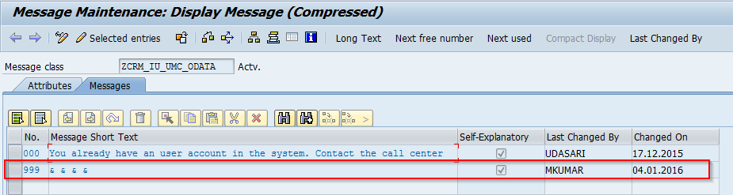

BADI/Enhancement Description

BADI Definition | Implementation name | Methods | Comments

Enhancement | Main Program | Includes | Form Routines

Custom Tables/Structure in SAP
N/A

Structure Name
Short text
Size category
Table maintenance allowed
Data class
Buffering
Table maintenance generation
Authorization Group
Field Name | Data Element | Domain | Type | Length | Check Table-Field | Key Field | Foreign Key | Description
Comments

Error Handling

--N/A--

Error Messages
Describe the expected error messages for different error conditions.

Error Message Number | Error Message Text (70 characters) | Error Conditions
ZCRM_IU_UMC_ODATA(999) | String regarding PO Box and Street Number validation | Validate PO Box or Street Number of Mailing address of CA

Security Requirements/ Authorization Details

--N/A--

Unit Test Plan

Refer to project test plan

